Dbnet training

Use training data ICDAR2015 only, because all images size is same. 1280x720

# - type: IaaAugment # 使用imgaug进行变换 ( 這都關掉 )

trainer: epochs: 10, log_iter: 1, batch_size: 32, num_workers: 20

validate: short_size: 736, batch_size: 32, num_workers: 20

preprocess and train time : 150 sec

2023-02-09 10:06:48,041 DBNet.pytorch INFO: [5/10], train_loss: 1.6258,

time: 147.5375, lr: 0.0007428824043550733

Batch time: 1 sec

2023-02-09 10:06:46,759 DBNet.pytorch INFO: [5/10], [31/32], global_step: 159, speed: 31.0 samples/sec,

2023-02-09 10:06:47,025 DBNet.pytorch INFO: [5/10], [32/32], global_step: 160, speed: 30.1 samples/sec,

Validation time: 130 sec

2023-02-09 10:04:20,368 DBNet.pytorch INFO: FPS:46.174830204754784

training

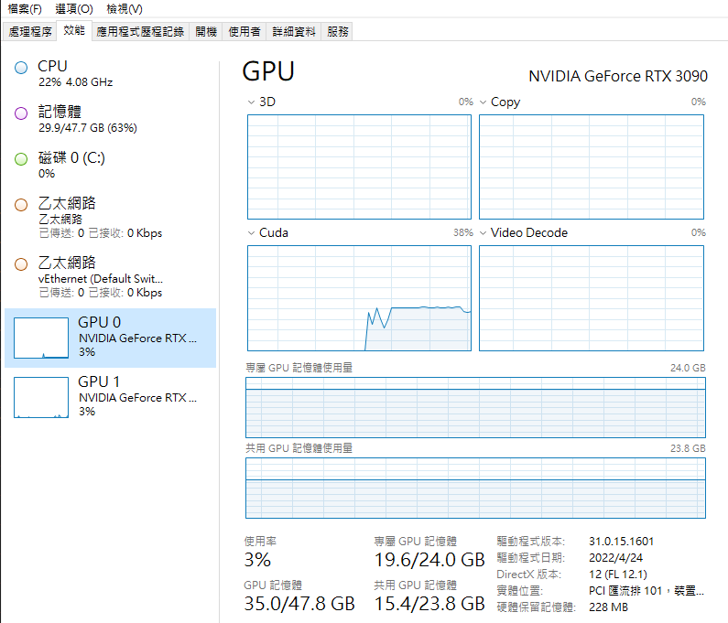

Valid

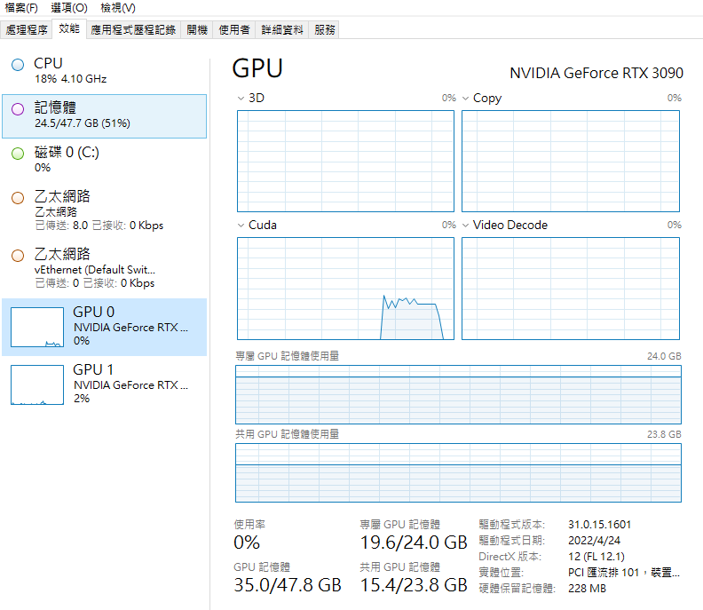

結果: batch 32 num_worker 20 讓訓練(使用GPU)時每個batch非常快，但是準備資料時間很久大約 120 sec !? 所以總時間還是大約 150 sec。valida時間大約120秒。

Dbnet training

Use training data ICDAR2015 only, because all images size is same. 1280x720

- type: IaaAugment # 使用imgaug进行变换 ( 這打開 )

args:

- {'type':Fliplr, 'args':{'p':0.5}}

- {'type': Affine, 'args':{'rotate':[-10,10]}}

- {'type':Resize,'args':{'size':[0.5,3]}}

trainer: epochs: 10, log_iter: 1, batch_size: 32, num_workers: 20

validate: short_size: 736, batch_size: 32, num_workers: 20

2023-02-09 10:35:40,543 DBNet.pytorch INFO: [3/10], [32/32], global_step: 96, speed: 30.1 samples/sec,

2023-02-09 10:35:41,590 DBNet.pytorch INFO: [3/10], train_loss: 2.1344, time: 151.7932,

2023-02-09 10:37:52,574 DBNet.pytorch INFO: FPS:35.07989322434386

2023-02-09 10:39:48,452 DBNet.pytorch INFO: [4/10], [1/32], global_step: 97, speed: 0.3 samples/sec,

結果: 情況差不多，訓練大約150秒，測試大約130秒

Dbnet training

Use training data ICDAR2015 only, because all images size is same. 1280x720

- type: IaaAugment # 使用imgaug进行变换 ( 這打開 )

args:

- {'type':Fliplr, 'args':{'p':0.5}}

- {'type': Affine, 'args':{'rotate':[-10,10]}}

- {'type':Resize,'args':{'size':[0.5,3]}}

trainer: epochs: 10, log_iter: 1, batch_size: 32, num_workers: 10

validate: short_size: 736, batch_size: 32, num_workers: 10

結果:這可以將訓練加速到大約 95秒，驗證加速到 70秒

Dbnet training

Use training data ICDAR2015 only, because all images size is same. 1280x720

- type: IaaAugment # 使用imgaug进行变换 ( 這打開 )

args:

- {'type':Fliplr, 'args':{'p':0.5}}

- {'type': Affine, 'args':{'rotate':[-10,10]}}

- {'type':Resize,'args':{'size':[0.5,3]}}

trainer: epochs: 10, log_iter: 1, batch_size: 32, num_workers: 6

validate: short_size: 736, batch_size: 2, num_workers: 16

結果:這可以將訓練加速到大約 75秒，驗證加速到 100秒

Dbnet training

Use training data ICDAR2015 only, because all images size is same. 1280x720

- type: IaaAugment # 使用imgaug进行变换 ( 這打開 )

args:

- {'type':Fliplr, 'args':{'p':0.5}}

- {'type': Affine, 'args':{'rotate':[-10,10]}}

- {'type':Resize,'args':{'size':[0.5,3]}}

trainer: epochs: 10, log_iter: 1, batch_size: 40, num_workers: 8

validate: short_size: 736, batch_size: 40, num_workers: 8

結果: 這可以將訓練加速到大約 85秒，驗證加速到 60秒

Dbnet training

Use training data ICDAR2015 only, because all images size is same. 1280x720

- type: IaaAugment # 使用imgaug进行变换 ( 這打開 )

args:

- {'type':Fliplr, 'args':{'p':0.5}}

- {'type': Affine, 'args':{'rotate':[-10,10]}}

- {'type':Resize,'args':{'size':[0.5,3]}}

trainer: epochs: 10, log_iter: 1, batch_size: 32, num_workers: 4

validate: short_size: 736, batch_size: 32, num_workers: 4

結果: 這可以將訓練加速到大約 60秒，驗證加速到 40秒

Dbnet training

Use training data ICDAR2015 only, because all images size is same. 1280x720

- type: IaaAugment # 使用imgaug进行变换 ( 這打開 )

args:

- {'type':Fliplr, 'args':{'p':0.5}}

- {'type': Affine, 'args':{'rotate':[-10,10]}}

- {'type':Resize,'args':{'size':[0.5,3]}}

trainer: epochs: 10, log_iter: 1, batch_size: 16, num_workers: 4

validate: short_size: 736, batch_size: 16, num_workers: 4

結果: 這可以將訓練加速到大約 60秒，驗證加速到 40秒

Dbnet training

Use training data ICDAR2015 only, because all images size is same. 1280x720

- type: IaaAugment # 使用imgaug进行变换 ( 這打開 )

args:

- {'type':Fliplr, 'args':{'p':0.5}}

- {'type': Affine, 'args':{'rotate':[-10,10]}}

- {'type':Resize,'args':{'size':[0.5,3]}}

trainer: epochs: 10, log_iter: 1, batch_size: 12, num_workers: 4

validate: short_size: 736, batch_size: 12, num_workers: 4

結果: 這可以將訓練加速到大約 60秒，驗證加速到 40秒

Dbnet training

Use training data ICDAR2015 only, because all images size is same. 1280x720

- type: IaaAugment # 使用imgaug进行变换 ( 這打開 )

args:

- {'type':Fliplr, 'args':{'p':0.5}}

- {'type': Affine, 'args':{'rotate':[-10,10]}}

- {'type':Resize,'args':{'size':[0.5,3]}}

trainer: epochs: 10, log_iter: 1, batch_size: 32, num_workers: 2

validate: short_size: 736, batch_size: 32, num_workers: 2

結果: 這可以將訓練加速到大約 50秒，驗證加速到 30秒

Dbnet training

Use training data ICDAR2015 only, because all images size is same. 1280x720

- type: IaaAugment # 使用imgaug进行变换 ( 這打開 )

args:

- {'type':Fliplr, 'args':{'p':0.5}}

- {'type': Affine, 'args':{'rotate':[-10,10]}}

- {'type':Resize,'args':{'size':[0.5,3]}}

trainer: epochs: 10, log_iter: 1, batch_size: 32, num_workers: 1

validate: short_size: 736, batch_size: 32, num_workers: 1

結果: 這可以將訓練加速到大約 70秒，驗證加速到 小於30秒；16樣本/秒

Dbnet training

Use training data ICDAR2015 only, because all images size is same. 1280x720

- type: IaaAugment # 使用imgaug进行变换 ( 這打開 )

args:

- {'type':Fliplr, 'args':{'p':0.5}}

- {'type': Affine, 'args':{'rotate':[-10,10]}}

- {'type':Resize,'args':{'size':[0.5,3]}}

trainer: epochs: 10, log_iter: 1, batch_size: 32, num_workers: 0

validate: short_size: 736, batch_size: 32, num_workers: 0, FPS 54

10 sample/sec

結果: 這可以將訓練加速到大約 100秒，驗證加速到 30秒

設定num_workers=0時GPU使用率會一波一波的跳。

Dbnet training

Use training data ICDAR2015 only, because all images size is same. 1280x720

- type: IaaAugment # 使用imgaug进行变换 ( 這打開 )

args:

- {'type':Fliplr, 'args':{'p':0.5}}

- {'type': Affine, 'args':{'rotate':[-10,10]}}

- {'type':Resize,'args':{'size':[0.5,3]}}

trainer: epochs: 10, log_iter: 1, batch_size: 32, num_workers: 3

validate: short_size: 736, batch_size: 32, num_workers: 1

結果: 這可以將訓練加速到大約 小於55秒，驗證加速到 小於30秒

結論: 同樣條件下最好的設定是

trainer: epochs: 10, log_iter: 1, batch_size: 32, num_workers: 2

validate: short_size: 736, batch_size: 32, num_workers: 1

結果: 這可以將訓練加速到大約 小於50秒，驗證加速到 小於30秒

測試2GPU 結果:在win環境下無法

Data:

Train: ICDAR2015 100 + ICDAR 2019 100

Test: ICDAR2015 50 + ICDAR 2019 50

Issue :

validate: short_size: 736, batch_size: 32, num_workers: 1

會錯，因為image size不同!?

Dbnet training

Use training data ICDAR2015 only, because all images size is same. 1280x720

- type: IaaAugment # 使用imgaug进行变换 ( 這打開 )

args:

- {'type':Fliplr, 'args':{'p':0.5}}

- {'type': Affine, 'args':{'rotate':[-10,10]}}

- {'type':Resize,'args':{'size':[0.5,3]}}

trainer: epochs: 10, log_iter: 1, batch_size: 32, num_workers: 2

validate: short_size: 736, batch_size: 1, num_workers: 1

結果: 這可以將訓練加速到大約24秒，驗證加速到 26秒

Dbnet training

Use training data ICDAR2015 only, because all images size is same. 1280x720

- type: IaaAugment # 使用imgaug进行变换 ( 這打開 )

args:

- {'type':Fliplr, 'args':{'p':0.5}}

- {'type': Affine, 'args':{'rotate':[-10,10]}}

- {'type':Resize,'args':{'size':[0.5,3]}}

trainer: epochs: 10, log_iter: 1, batch_size: 32, num_workers: 4

validate: short_size: 736, batch_size: 1, num_workers: 8

32 sample/sec ,FPS 18

結果: 這可以將訓練加速到大約32秒，驗證加速到55秒

Dbnet training

Use training data ICDAR2015 only, because all images size is same. 1280x720

- type: IaaAugment # 使用imgaug进行变换 ( 這打開 )

args:

- {'type':Fliplr, 'args':{'p':0.5}}

- {'type': Affine, 'args':{'rotate':[-10,10]}}

- {'type':Resize,'args':{'size':[0.5,3]}}

trainer: epochs: 10, log_iter: 1, batch_size: 32, num_workers: 2

validate: short_size: 736, batch_size: 1, num_workers: 2

32 sample/sec ,FPS

結果: 這可以將訓練加速到大約23秒，驗證加速到26秒

===========================================

實際應用

=============================================

C:\Application\Develop\annotation_tools\annotation_utils

mkdir C:\Application\Develop\datasets\prepare\train

mkdir C:\Application\Develop\datasets\prepare\train\img

mkdir C:\Application\Develop\datasets\prepare\train\gt

mkdir C:\Application\Develop\datasets\prepare\test

mkdir C:\Application\Develop\datasets\prepare\test\img

mkdir C:\Application\Develop\datasets\prepare\test\gt

number of ICDAR2015 test images : 500

number of ICDAR2015 train images : 250

number of ICDAR2019 train images : 500

number of ICDAR2019 test images : 250

number of selfdata train images : 330

number of selfdata test images : 236

number of selfdata_vertical train images : 386

number of selfdata_vertical test images : 17

gen train.txt , test.txt.

Dbnet training

- type: IaaAugment # 使用imgaug进行变换 ( 這打開 )

args:

- {'type':Fliplr, 'args':{'p':0.5}}

- {'type': Affine, 'args':{'rotate':[-10,10]}}

- {'type':Resize,'args':{'size':[0.5,3]}}

trainer: epochs: 10, log_iter: 1, batch_size: 32, num_workers: 2

validate: short_size: 736, batch_size: 1, num_workers: 2

結果: 這可以將訓練加速到大約140秒，驗證加速到120秒

Dbnet training

- type: IaaAugment # 使用imgaug进行变换 ( 這打開 )

args:

- {'type':Fliplr, 'args':{'p':0.5}}

- {'type': Affine, 'args':{'rotate':[-10,10]}}

- {'type':Resize,'args':{'size':[0.5,3]}}

trainer: epochs: 10, log_iter: 1, batch_size: 32, num_workers: 4

validate: short_size: 736, batch_size: 1, num_workers: 4

結果: 這可以將訓練加速到大約105秒，驗證加速到105秒

Dbnet training

- type: IaaAugment # 使用imgaug进行变换 ( 這打開 )

args:

- {'type':Fliplr, 'args':{'p':0.5}}

- {'type': Affine, 'args':{'rotate':[-10,10]}}

- {'type':Resize,'args':{'size':[0.5,3]}}

trainer: epochs: 10, log_iter: 1, batch_size: 32, num_workers: 8

validate: short_size: 736, batch_size: 1, num_workers: 8

結果: 這可以將訓練加速到大約115秒，驗證加速到120秒

Dbnet training

- type: IaaAugment # 使用imgaug进行变换 ( 這打開 )

args:

- {'type':Fliplr, 'args':{'p':0.5}}

- {'type': Affine, 'args':{'rotate':[-10,10]}}

- {'type':Resize,'args':{'size':[0.5,3]}}

trainer: epochs: 10, log_iter: 1, batch_size: 32, num_workers: 6

validate: short_size: 736, batch_size: 1, num_workers: 6

結果: 這可以將訓練加速到大約100秒，驗證加速到130秒

Dbnet training

- type: IaaAugment # 使用imgaug进行变换 ( 這打開 )

args:

- {'type':Fliplr, 'args':{'p':0.5}}

- {'type': Affine, 'args':{'rotate':[-10,10]}}

- {'type':Resize,'args':{'size':[0.5,3]}}

trainer: epochs: 10, log_iter: 1, batch_size: 32, num_workers: 6

validate: short_size: 736, batch_size: 1, num_workers: 4

FPS 16 speed 22

結果: 這可以將訓練加速到大約108秒，驗證加速到105秒